**VPM's K.G. Joshi College of Arts and N.G. Bedekar College of Commerce (Autonomous), Thane**

**Activity Report**

**1. Name of the Activity:Study Tour**

**2. Name of the Department: Sanskrit/Philosophy**

**3 Day & Date: 14th February 2025**

**4.Venue:  कोराई दुर्ग:,कार्ला लेणी,नारायणी धाम**

**5. Resource Person:  -**

**6. Number of  Participants :  Male-5  Female- 17 Total-22**

**7. Purpose of the Activity: A Study Tour is an educational trip designed to enhance students' learning experiences by offering real exposure to topics studied in the classroom. The purpose of organizing a study tour for college students includes:**

1. **Practical Learning and Real-World Exposure  
    Study tours provide students with opportunities to apply theoretical knowledge to real-world situations, allowing them to understand concepts better and make connections between classroom learning and practical experiences.**
2. **Cultural Awareness and Broadening Horizons  
    A study tour can expose students to different cultures, traditions, and environments, helping them gain broader perspectives and become more globally aware and open-minded.**
3. **Enhancing Critical Thinking and Observation Skills  
    By visiting historical sites, industries, or natural landscapes, students are encouraged to observe, analyze, and think critically, which strengthens their problem-solving and analytical abilities.**
4. **Building Teamwork and Social Skills  
    Traveling in groups fosters teamwork and collaboration. Students learn how to interact with peers, share responsibilities, and develop interpersonal skills in a real-world context.**
5. **Encouraging Personal Growth and Independence  
    A study tour encourages students to become more independent, manage time effectively, and take responsibility for their actions, contributing to personal development.**
6. **Enhancing Subject Knowledge  
    Whether it’s a tour to a historical site, museum, factory, or corporate office, students gain a deeper understanding of their subjects through firsthand experience, making the learning process more engaging and memorable.**
7. **Fostering Career Exploration  
    For students exploring various career paths, study tours provide an opportunity to visit industries, institutions, or offices where they can gain insights into different professions and industries, helping them make informed career choices.**
8. **Memorable Learning Experience  
    The experiences gained during a study tour are often memorable and can be a source of inspiration for future academic or career pursuits, making it a fun yet educational part of their journey.**

**7. Gist of the Activity: Study Tour for Students**

**A Study Tour for students is an educational trip that offers hands-on learning experiences beyond the classroom. The tour aims to enhance students’ understanding of their subjects by exposing them to real-world applications, fostering cultural awareness, and encouraging critical thinking. It also provides opportunities for personal growth, teamwork, and career exploration, making learning more engaging and memorable.**

**8. Teacher Incharge :-  Asst. Prof. Swati Bhalerao / Asst. Prof. Rohini Joshi/ Dr. Avinash Waghmare/  Asst. Prof. Supriya More/ Asst. Prof. Anvi Thatte.**

**Thanks and Regards**

**Asst. Prof. Swati M. Bhalerao  Dr. Suchitra A. Naik**

**HoD Sanskrit Principal**

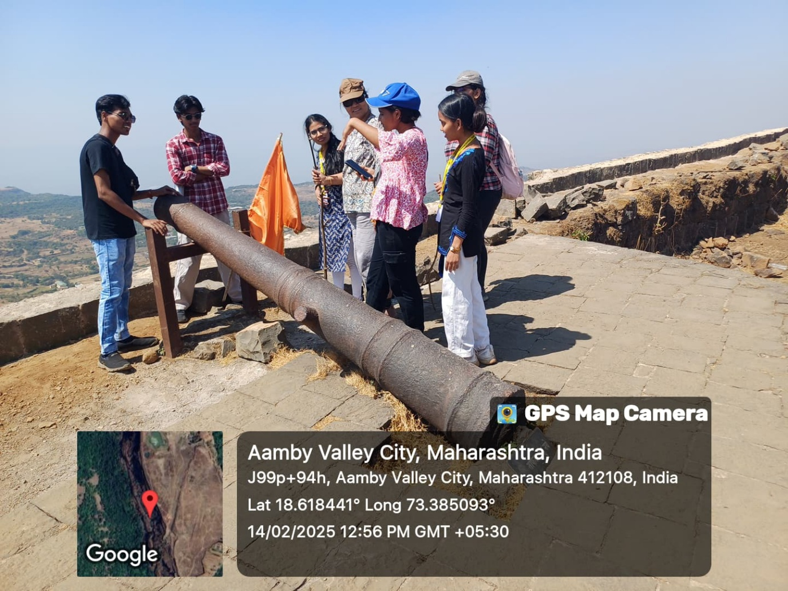

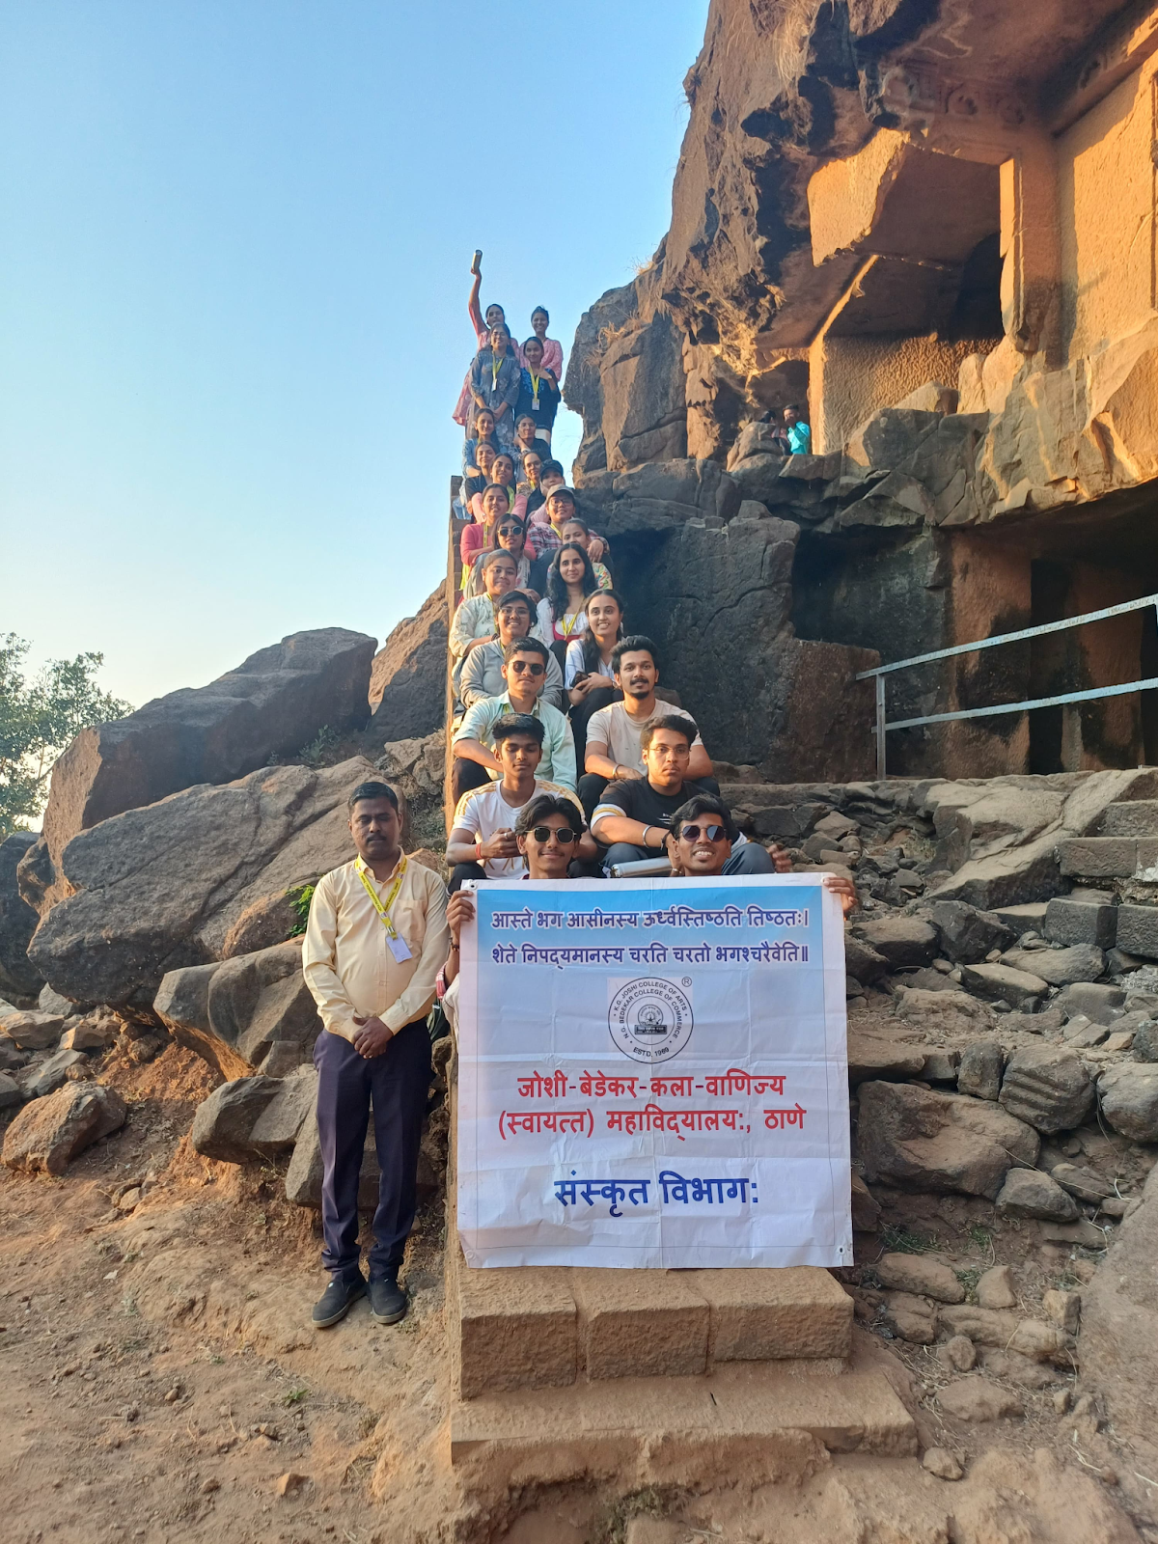

**Study Tour 14th February 2025  Venue:  कोराई दुर्ग:,कार्ला लेणी,नारायणी धाम**